Notification of Closure of Chubu Branch Office

Greetings

Let me express our heartfelt appreciation for your business and continued support.

As part of our streamlining of operations, we herewith announce the closure of our Branch Office in Nagoya. Three divisions at our headquarters in Tokyo mentioning below will take over all the business and services of branch office by the end of upcoming March.

So as not to cause any unnecessary inconvenience to our valued customers due to this closure of our own convenience, we will strive with our utmost to implement smooth and rapid transfer of full responsibilities of the branch office to the above mentioned three successor divisions.

Moreover we will renew our resolution and further try to enhance and strengthen our services to you in order to earn your trust and satisfaction always.

Notice
Closure date: End of March 2017
Transfer of the business to the following divisions:
Spice Division （03-3555-5501・5502）
Foods Division （03-3555-5506・5507）
Agriculture Division (03-3555-5508・5511）

Thank you for your understanding in this matter, and hope for your continued trust into the future.

Yours faithfully

January 18, 2017

Vox Trading Co., Ltd.

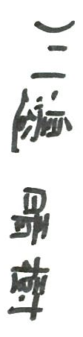

Haruki KAWABE, CEO

